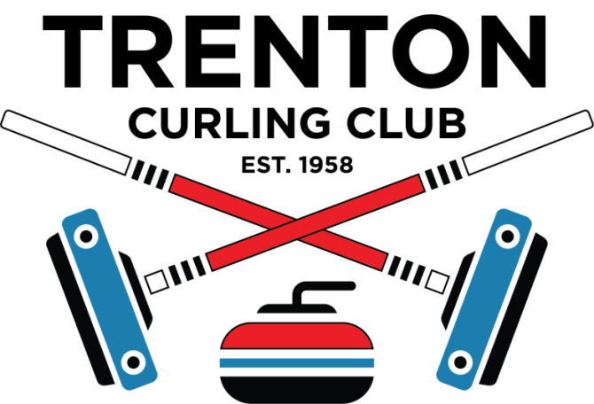 | REGISTRATION FORM
COMMUNITY CURLING DAY…..SATURDAY JANURY 18, 2025…..
TRENTON CURLING CLUB

 | $200 PER TEAM PLUS GIFT BASKET* | ….. for Raffle Table
 | Payment due by Friday, December 6th … Payment will hold your spot!
Send a completed registration form and e-transfer via email to: trentoncurling@hotmail.com.

A registration form and cheque may also be dropped off at our club or sent by regular mail to: Trenton Curling Club, 293 King Street, Trenton, ON K8V 3X4
No refunds after Friday, December 6th, 2024.

First Name | Last Name | Email | Phone | Are you a curler? | Emergency Contact  Name | Phone
The Team Contact is the first person on this list. All information will be sent to the Team Contact, who is asked to forward it to team mates.

